**1. Ligand and receptor preprocessing and simulation system construction.**

*estrogen receptor alpha and androgen receptor crystal structure preprocessing in the Protein Data Bank database.* The estrogen receptor alpha (ERα) or androgen receptor (AR) dimer consists of two monomers, referred to as Monomer 1 and Monomer 2 for simplicity. Each monomer corresponds to a ligand and a coregulator, with Monomer 1 associated with Ligand 1 and Coregulator 1, and Monomer 2 corresponding to Ligand 2 and Coregulator 2. The receptor protein in the obtained ERα and AR crystal structure was preprocessed as follows: first, Swiss-PdbViewer was used to check the integrity of the crystal structure and to supplement missing amino acid residues. Then, PyMOL was used for hydrogenation of the crystal structure. The following systems were constructed:

(1) Ligand-receptor monomer system: Monomer 1 and Ligand 1 form a complex (ERα example, as shown in Figure 1A).

(2) Ligand-receptor monomer-coregulator system: Monomer 1, Ligand 1, and Coregulator 1 form a mixed system (ERα example, as shown in Figure 1B).

(3) Ligand-receptor dimer system: Monomer 1, Monomer 2, Ligand 1, and Ligand 2 form a mixed system (ERα example, as shown in Figure 1C).

(4) Ligand-receptor dimer-coregulator system: Monomer 1, Monomer 2, Ligand 1, Ligand 2, Coregulator 1, and Coregulator 2 form a mixed system (ERα example, as shown in Figure 1D).

Additionally, the extracted ligands were hydrogenated and assigned a force field. Ligand files were converted to the .mol2 format using Open Babel software and the force field was assigned using Swiss-Param.

*ERα and AR initial state construction and molecular docking for bisphenols and hydroxylated polybrominated diphenyl ethers.* The SMILES strings of the test chemicals were obtained from the PubChem database (https://pubchem.ncbi.nlm.nih.gov/). These SMILES strings were used to construct the chemical structures in ChemDraw 2014 software. The structures were then optimized using the MM2 force field in Chem3D 2014, followed by further optimization using the Powell gradient algorithm and Tripos force field in the Minimize module of SYBYL 7.3 (Tripos Inc., USA). The optimized structures were assigned Gasteiger-Huckel charges and used as the initial structure for docking.

ERα and AR initial state structures were constructed using homology modeling in the Swiss-Model online server (https://swissmodel.expasy.org/). The ERα template removed helix 11 (H11) and flexible loop between H11 and helix 12 (H12), and repositioned H12. The constructed receptor structures were evaluated using Ramachandran plots.

Molecular docking was performed using the docking suite module in SYBYL 7.3, with the Surflex-Dock method and automatic search settings to identify the binding pocket. The rest of the parameters in the docking operation were set to their default values. The top 10 docking poses for each chemical were generated, and the pose with the highest docking score was selected for further analysis and molecular dynamics simulations.

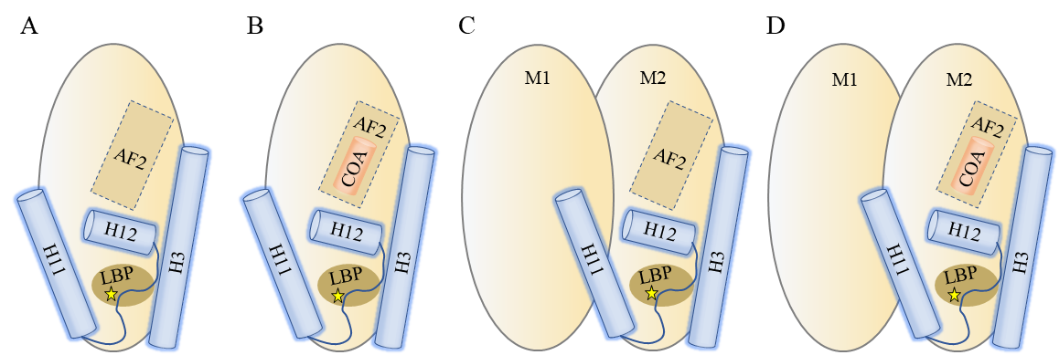

Figure 1. Schematic diagram of construction systems. (A) Ligand- estrogen receptor alpha (ERα) monomer system. (B) Ligand-ERα monomer-coregulator system. (C) Ligand-ERα dimer system. (D) Ligand-ERα dimer-coregulator system.

**2. Molecular dynamics simulation.**

The receptor protein was assigned the CHARMM 27 force field. The complex was solvated in a TIP3P water model, ensuring a distance of at least 1.4 nm between the complex edge and the water layer. Sodium or chloride ions were added to balance the charge of the system. Energy minimization was performed using the steepest-descent method. System equilibration was carried out in two steps, first in the NVT ensemble (constant volume and temperature), followed by NPT (constant pressure and temperature). The simulation environment and simulation time were set, with the PME method used to calculate long-range electrostatic interactions and the LINCS (Linear Constraint Solver) method applied for bond constraints. The molecular dynamics simulation was then completed. The simulation environment included standard atmospheric pressure (1 atm) and a temperature of 300 K.

**3. Binding free energy calculation.**

From the molecular dynamics simulation trajectory, 100 conformations were extracted. The binding free energies of the four systems were calculated using the Molecular Mechanics Poisson-Boltzmann Surface Area (MM-PBSA) method.

**4. Trajectory analysis.**

The simulation trajectories were analyzed using R software's Bio3d package for dynamic cross-correlation map (DCCM) of Cα atom motions. In addition, for ligand-ERα monomer-coregulator and ligand-ER dimer-coregulator complexes, hydrogen bond occupancy ratios between coregulators and receptor proteins were calculated based on the dynamic simulation results. Hydrogen bonds were defined as those with a distance of ≤ 3.5 Å and an angle threshold of 120°.